**Project Design Phase-II**

**Data Flow Diagram & User Stories**

|  |  |
| --- | --- |
| Date | 03 October 2022 |
| Team ID | PNT2022TMID08185 |
| Project Name | Project - Exploratory analysis of rainfall data in India for agriculture |
| Maximum Marks | 4 Marks |

**Data Flow Diagrams:**

A Data Flow Diagram (DFD) is a traditional visual representation of the information flows within a system. A neat and clear DFD can depict the right amount of the system requirement graphically. It shows how data enters and leaves the system, what changes the information, and where data is stored.

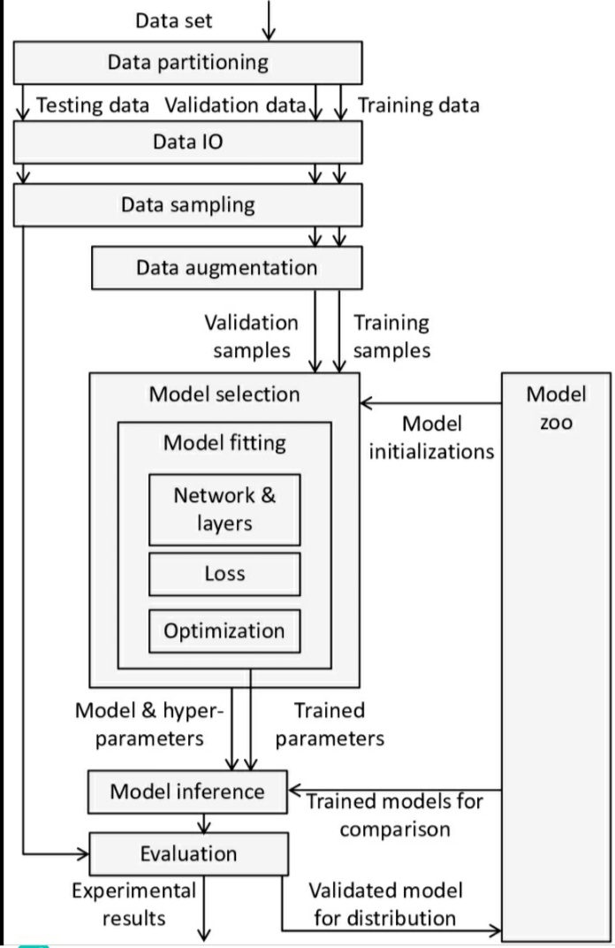

1)User configures credentials for the language understanding service and starts the the app.

2)Data file is to be selected to process and load.

3)Apache Tika extracts text from the data file.

4)Extracted text is passed fo enrichment.

5)Enriched data is visualized in the UI using python library.

**User Stories**

Use the below template to list all the user stories for the product.

| **User Type** | **Functional Requirement (Epic)** | **User Story Number** | **User Story / Task** | **Acceptance criteria** | **Priority** | **Release** |
| --- | --- | --- | --- | --- | --- | --- |
| Customer (Mobile user) | Registration | USN-1 | As a user, I can register for the application by entering my email, password, and confirming my password. | I can access my account / dashboard | High | Sprint-1 |
|  |  | USN-2 | As a user, I will receive confirmation email once I have registered for the application | I can receive confirmation email & click confirm | High | Sprint-1 |
|  |  | USN-3 | As a user, I can register for the application through Facebook | I can register & access the dashboard with Facebook Login | Low | Sprint-2 |
|  |  | USN-4 | As a user, I can register for the application through Gmail |  | Medium | Sprint-1 |
|  | Login | USN-5 | As a user, I can log into the application by entering email & password |  | High | Sprint-1 |
|  | Dashboard | USN-6 | In dashboard, user can login using Mobile number | I will be getting an One Time Password (OTP) | High | Sprint-1 |
| Customer (Web user) |  | USN-7 | This weather app alerts you when rain is approaching |  |  |  |
| Customer Care Executive |  |  | The alerts are a reliable Short term forecast based on near real time data. | Location access is mandatory |  | Sprint-3 |
| Administrator |  |  | This more precise and reliable than a traditional forecast. |  |  | Sprint-4 |